Large Lithospheric Seismic Velocity Variations Across the Northern Canadian Cordillera Imaged by Ambient Noise Tomography.

Derek L. Schutt^{1*}, Robert W. Porritt², Clément Estève³, Pascal Audet⁴, Jeremy Gosselin⁵, Andrew Schaeffer⁶, Richard C. Aster⁷, Jeffrey T. Freymueller⁸, Joel F. Cubley⁹

¹Department of Geosciences, Warner College of Natural Resources and Colorado State University, Fort Collins, CO
²Sandia National Laboratories, Jackson School of Geosciences, Albuquerque, NM
³Institut für Meteorologie und Geophysik, University of Vienna, Vienna, Austria
⁴Department of Earth and Environmental Sciences, University of Ottawa, ON
⁵Department of Geoscience, University of Calgary, Calgary, AB
⁶Geological Survey of Canada, Pacific Division, Sidney, BC
⁷Department of Geosciences, Warner College of Natural Resources and Colorado State University, Fort Collins, CO
⁸Department of Earth and Environmental Sciences, Michigan State University, East Lansing, MI
⁹Centre for Northern Innovation in Mining, Yukon University, Whitehorse, YT

*Corresponding Author: derek.schutt@colostate.edu

Global-scale seismic velocity models of the Northern Canadian Cordillera show high velocities to the east of the Cordilleran deformation front and low velocities to the west. This velocity contrast is consistent with other geophysical observables, such as regional seismological studies, that indicate a weak and thin lithosphere to the west that transitions quickly to a strong and thick craton-like lithosphere at the deformation front. We present new results using data collected by the Mackenzie Mountains EarthScope Project, which included an ~875 km-long line of 40 broadband seismographs across the Cordillera and into the craton extending from roughly Skagway, Alaska to Great Bear Lake, Northwest Territories. The 3-year overlap of this deployment with other broadband seismic stations in the region, most notably the EarthScope Transportable Array and the Yukon Northwest Seismic Network, allows for detailed 3-D Rayleigh wave ambient noise imaging of the upper lithosphere. Results show large velocity variations west of the deformation front. Notably, we image a 5% Vs low that extends from the upper crust to the asthenospheric mantle. This plume-like structure, and associated weakening, may be a primary cause for the ongoing uplift of the Mackenzie Mountains at their unusually eastward location. We also image a low velocity feature in the lower crust extending to the west of the deformation front, which may facilitate eastward crustal translation along a large-scale (~800 km) decollement system driven by the Yakutat indentor consistent with the orogenic float hypothesis of Mazzotti and Hyndman (2002). We also note strong lithosphere-scale lateral heterogeneity suggesting that 3-D effects are important in focusing deformation in the Mackenzie Mountain area.
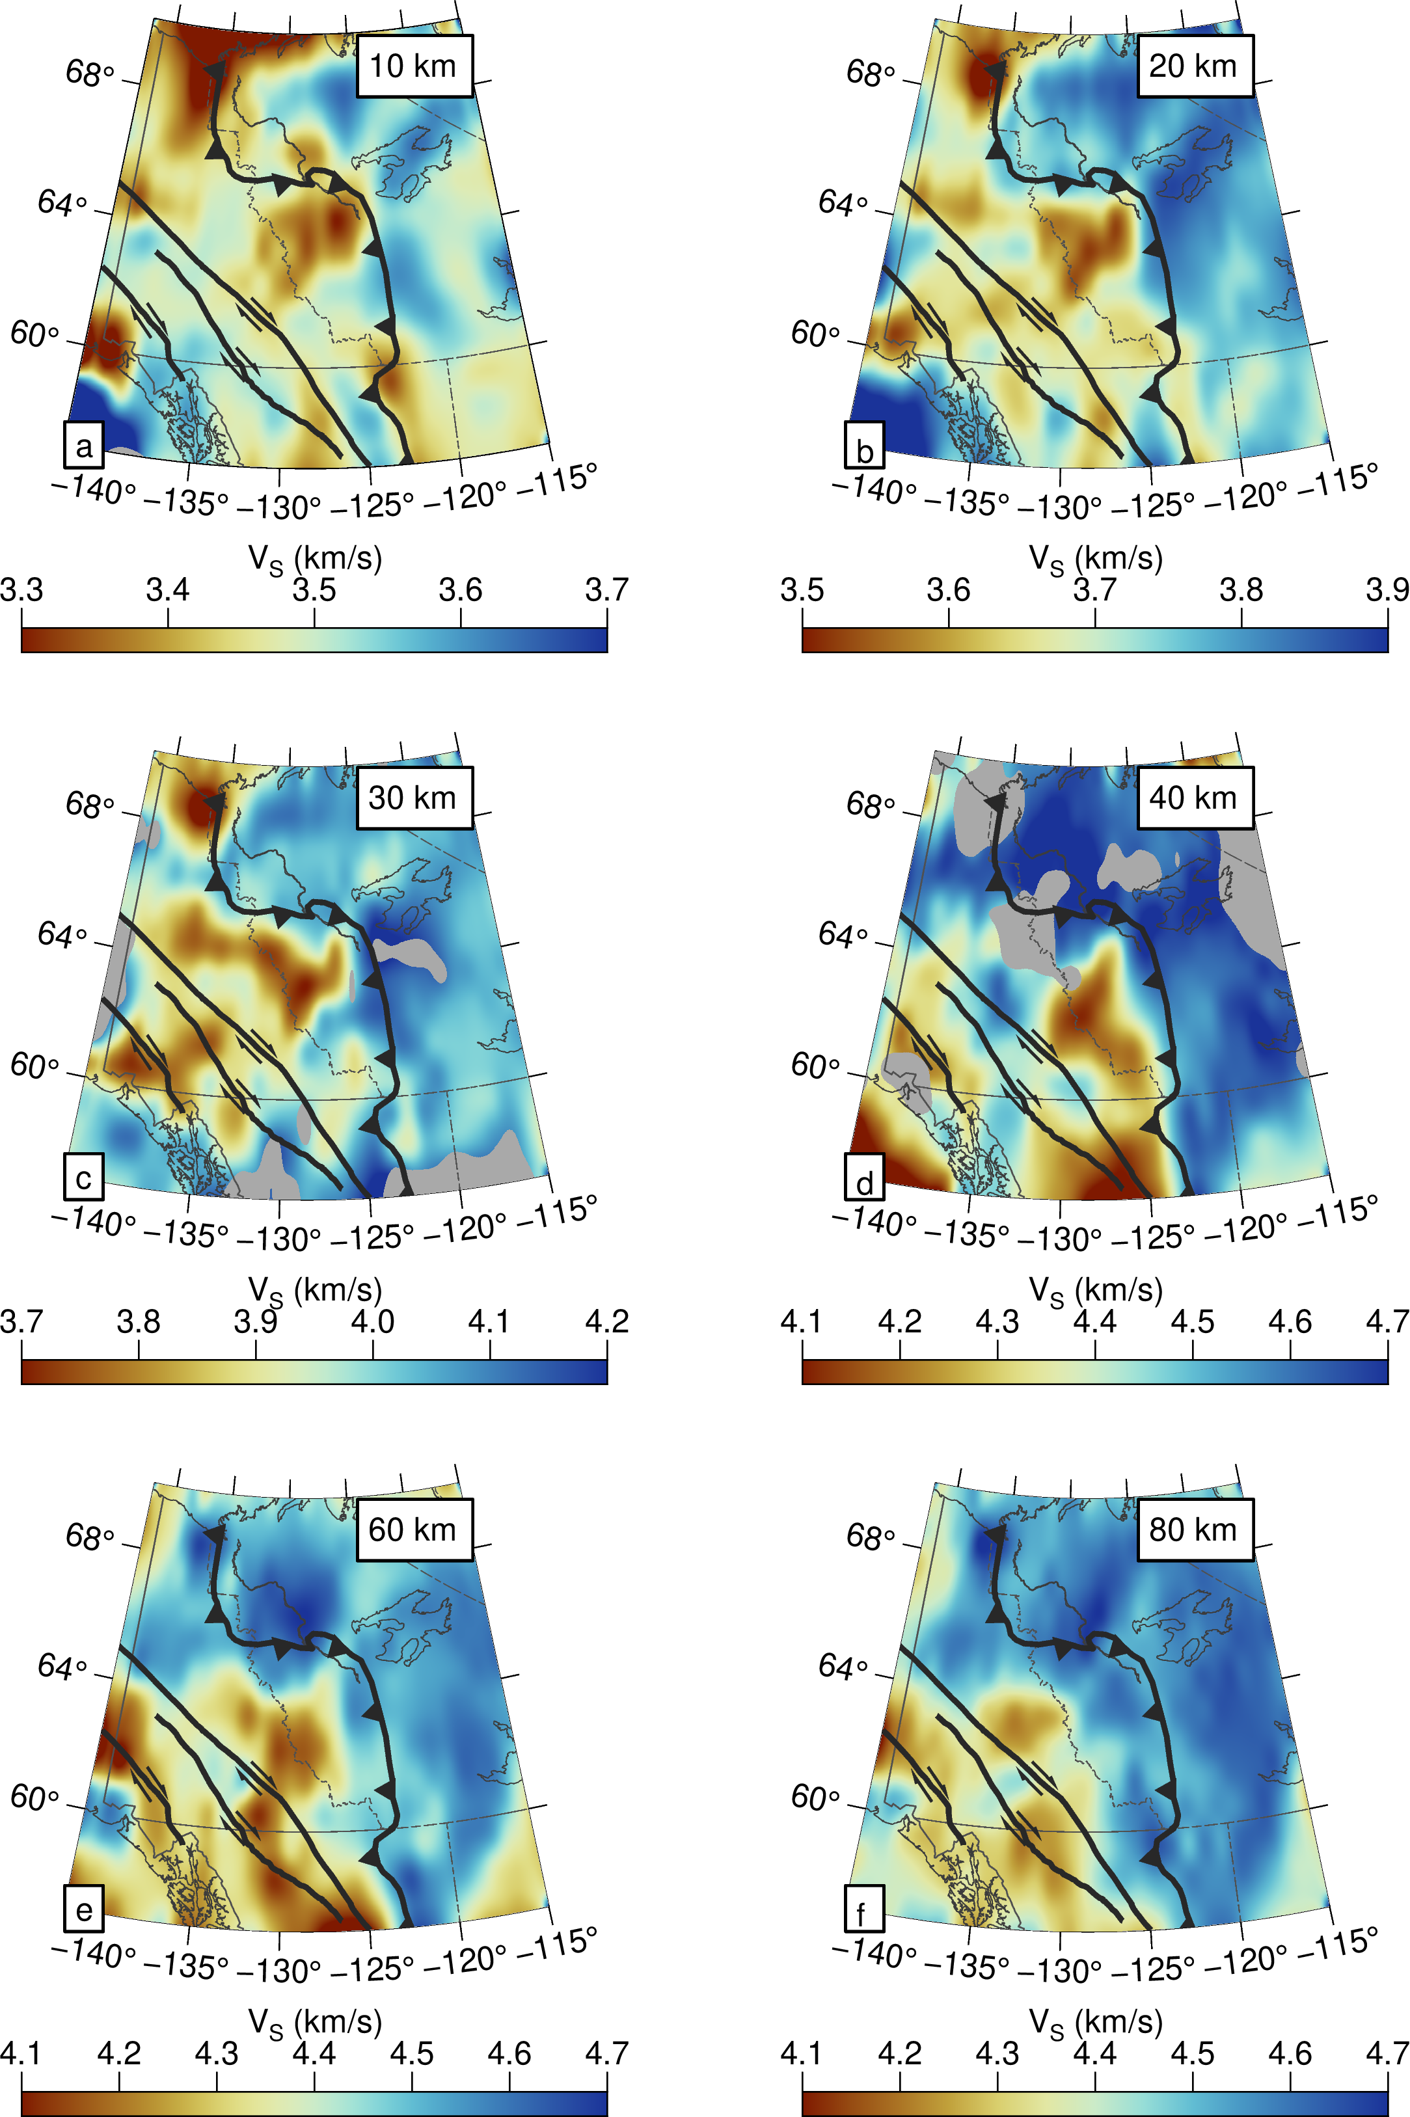

Figure: a-f) S-wave velocity under the Mackenzie Mountains and surroundings.

